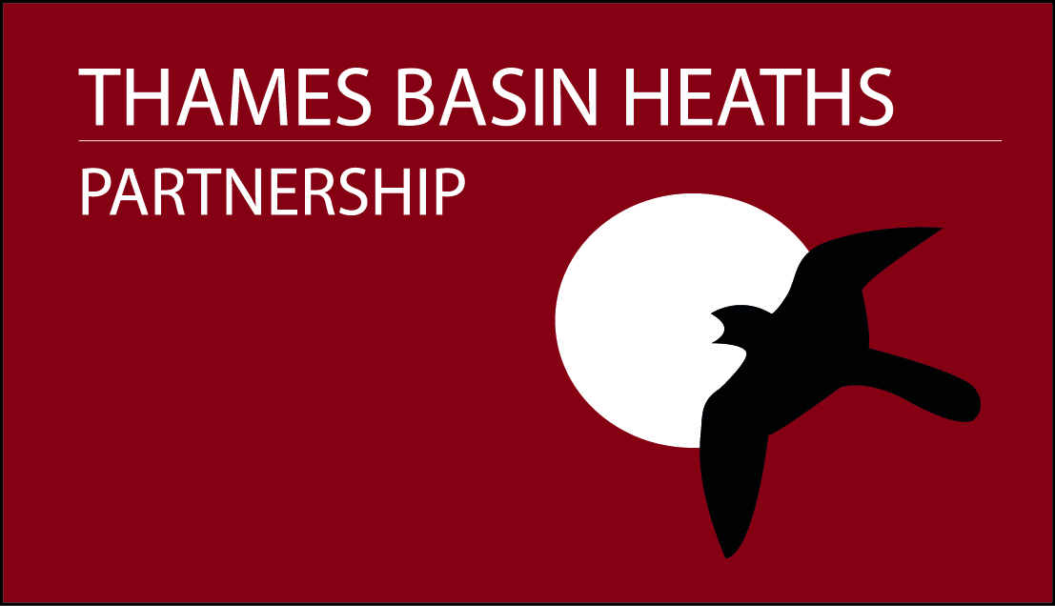

Seasonal Warden
Thames Basin Heaths Partnership

Job type: Short Term Appointment 1st March - 31 August 2021
Location: Flexible, but must be able to travel to the Thames Basin Heaths Special Protection Area on a daily basis, with the role requiring some weekend/early morning and evening work
Staff framework level: Adviser
Starting salary: £22,168
Hours: Full time: 37 hours per week

Hosted by Natural England, the Government’s adviser for the natural environment in England, the Thames Basin Heaths Partnership is looking for Seasonal Wardens for the Thames Basin Heaths Strategic Access Management and Monitoring project.

The team

Natural England has 12 area teams across England. Area teams deliver our front line in advice, incentives and regulation; they deliver locally across the breadth of our work, with customers, partners and other stakeholders, to make a significant contribution to outcomes for the natural environment.

This is a local role, based in Natural England's Thames Solent Area Team. You will be working as part of the Thames Basin Heaths Strategic Access Management and Monitoring (SAMM) project, one of the measures being used to avoid and mitigate against the impacts of housing development on the Thames Basin Heaths Special Protection Area (SPA). Working as part of a wardening team, you will be expected to be flexible, working largely outdoors, on-site, working from our office base at Heather Farm, near Woking.

Job description

Your work will include:

Educating all users of the SPA to value the heathland habitat and make informed decisions about how to behave in order to protect it; in particular, encouraging responsible dog walking through on-site wardening on foot across the SPA.

Discouraging negative recreational activities where they impact on the SPA and reporting and recording illegal activities (e.g. arson, dumping, reckless cycling, motorcycling).

Promoting the use of Suitable Accessible Natural Greenspace (SANG) sites as an alternative visitor destination.

You will:

Be willing and able to work outside, travelling independently to a variety of heathland sites and engaging with site users for much of your working day, which will involve negotiating uneven terrain, slopes and gates/stiles.

Be prepared to work flexibly and undertake some early morning and evening work and to work every other weekend or an equivalent number of weekend days. Have excellent attendance and time-keeping.

Have the ability to listen and communicate effectively with the public, land managers, partner organisations, and colleagues and have a good understanding of the principles of working with partner organisations to achieve common goals.

Have broad knowledge of the lowland heathland habitat and the pressures arising from housing development. A basic knowledge of the Wildlife and Countryside Act, Habitats Directives, CRoW and Town and Country Planning Act.

Have a keen desire to learn more about heathland and access management, heathland species, public engagement and partnership working.

Have a proven track record of proactive public engagement and using your initiative to arrange and lead events that engage and educate the public.

Be self-motivated, organised and enthusiastic and used to working without direct supervision, having a confident and innovative approach to developing ideas and projects.

Have a working knowledge of Microsoft Office Outlook, Excel and Word.

Have a full UK driving licence.

Be prepared to make use of your own vehicle, with appropriate business level insurance cover.

Qualifications

A-level / GCSE.
Degree / Postgraduate or relevant work experience.

Competencies

We'll assess you against these competencies during the selection process:

Personal effectiveness – (level: basic)

Use clear and appropriate language, communication styles and techniques that engage your audience.

Act with integrity, addressing challenging issues and managing conflict through being open and objective.

Use insight to identify target audiences and partners and to inform communication objectives, messages and solutions.

Work delivery – (level: practitioner)

Manage and deliver your work to agreed deadlines.
Handle data responsibly, understand your role in good governance, and comply with delegations, policies and procedures.
Apply the relevant methodologies for collecting and collating data/evidence.
Putting people at the heart of the environment – (level: basic)
Understand the importance of people accessing and engaging with the natural environment, and how to balance their needs with nature conservation objectives.

Deliver the environmental benefits that people and places need most and take practical steps to enhance opportunities for people to access, engage with, enjoy and take action for the environment.

Technical knowledge of heathland and public engagement – (level: basic)
Experience in inspiring people of all ages to engage with and learn to protect the natural environment.
Knowledge of heathland habitats and associated species and the pressures on local heathland sites from recreational use.

Benefits

Civil Service pension schemes may be available for successful candidates.
Travel expenses.

Things you need to know

Successful candidates must pass basic security checks.

Feedback will only be provided if you attend an interview or assessment.

Open to UK, Commonwealth and European Economic Area (EEA) and certain non EEA nationals. Further information on whether you are able to apply is available here.

The Civil Service Code sets out the standards of behaviour expected of civil servants.

We recruit by merit on the basis of fair and open competition, as outlined in the Civil Service Commission's recruitment principles.

The Civil Service embraces diversity and promotes equality of opportunity. There is a guaranteed interview scheme (GIS) for candidates with disabilities who meet the minimum selection criteria.

For more information contact Ann Conquest – 07747 040059 or ann.e.conquest@naturalengland.org.uk

Closing date – 30/11/2020

Interview dates – w/c 4th January 2021

