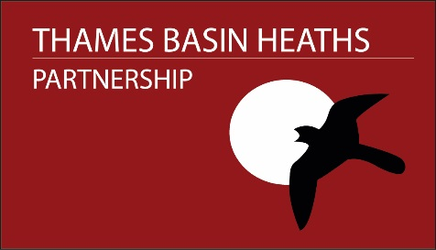

Thames Basin Heaths Partnership – Seasonal Warden role
Frequently Asked Questions
Who will I be working for?
You’ll be employed by Natural England, but will work exclusively for the Thames Basin Heaths Partnership, an externally funded project hosted by Natural England. You can find out more information on the year – round team you will be joining here
What are the main activities I will be doing?
We aim to maximise hours spent working outside on the Thames Basin Heaths Special Protection Area talking to visitors. To maximise our presence across the area, we often work alone. We work across the three counties of Surrey, Hampshire & Berkshire and a normal working day can involve quite a bit of travel. To maximise our time spent outside, we keep admin to a minimum, but there are a few responsibilities such as filling in weekly timesheets, claiming expenses monthly and submitting warden log data daily. We expect all team members to help with monthly car park surveys, which involve driving around following a pre-agreed route and recording parked vehicle numbers in collaboration with a colleague.
Will I need to wear a uniform?
You’ll be required to wear a branded uniform when working on site.
What is the requirement for weekend and evening/early morning work?
We expect all seasonal wardens to work 4 weekend days every month. Some occasional surveying may also be required early mornings or evenings. We support flexible working so we can discuss regular early morning and/or early evening work for the right candidate.
How will I travel around?
We have two/three project vans, but most of the time you’ll use your own car to go to site and you’re expected to show proof of business insurance cover, which you will have to arrange independently. You can claim a mileage allowance for using your own car (the equivalent of from home to site or from Heather Farm, Woking to site, whichever is less). Sustainable transport such as using your bike would also be an option for some local sites.
Can I work part time?
Part time work patterns may be able to be accommodated for the right candidate, but this must be a minimum of 3 days per week. Full time hours are preferable.

